

Master thesis for the Behavioral Economics program
Erasmus School of Economics, Rotterdam
Supervised by prof. Aurélien Baillon
Han-Thijs de Senerpont Domis
403070
Timeless Anomalies
Investigating the persistence and rationality of the World Cup Effect
Abstract
Researchers studying the effect of sporting events on stock returns found that losses in the FIFA World Cup lead to significant next-day market decline on the loser’s local stock market (Edmans, García, & Norli, 2007). A few years after the publication of the original effect, research was published on a simple strategy to exploit this effect using an aggregate effect on the U.S. stock market (Kaplanski & Levy, 2010a). The fact that a profitable strategy had been conceived based on this World Cup effect hinted towards market inefficiency.
Using the same methodologies as these researches, the effect was verified. Adding more recent data, the effect seemed to have diminished over time. When examining the effect in subsamples it became clear that the effect was influenced heavily by outliers, namely the 1974 and 2002 World Cup. The diminishing over time is thus explainable by the reduced influence of these outliers. Removing these outliers led to statistical insignificance for the effect (p-values .166 for loss games, .357 for event effect days and .742 for the entire period). Using actual market returns it was established that the effect had no economic significance either (the conceived strategy underperformed the market by 1,22%).

Table of contents

Introduction
1. Literature review
1.1 Market efficiency
1.2 Behavioral finance
1.3 The case of soccer
2.2. Concepts
2.1 Event studies
2.2 Betting odds
3. Analysis
3.1 Data description
3.2 Structure
3.3 Results
3.3.1 World Cup effect
3.3.2 Exploitability
3.3.3 Role of expectations
3.4 Findings
4. Conclusion
4.1 Discussion
4.2 Suggestions for future research
Bibliography
References
Other sources
Appendix

p. 1-2
p. 3-12
p. 3-6
p. 7-11
p. 11-12
p. 13-18
p. 14-15
p. 15-18
p. 19-36
p. 20
p. 20-23
p. 23-37
p. 24-29
p. 29-34
p, 34-35
p. 36
p. 37-41
p. 37-39
p. 40-41
p. 41-46
p. 41-45
p. 45-46
p. 46-48
Introduction
Market efficiency has been the subject of debate for decades now, with recent Nobel laureates Eugene F. Fama and Robert J. Shiller having started streams of research that continue today. The former’s work focuses on the Efficient Market Hypothesis (EMH) and how markets converge to equilibrium. The latter’s work challenges this EMH and examines behavior anomalous to efficient market behavior. The debate has many more participants, and the data and tools to investigate empirically if and how information is incorporated continue to improve. This research aims to contribute to the discussion by examining the behavior of a specific anomaly over time, thus considering the role of mood and expectations in market behavior.
A few years ago, researchers studying the effect of sporting events on stock returns made a peculiar finding, namely that losses in the FIFA World Cup lead to significant next-day market decline on the loser’s local stock market (Edmans, García, & Norli, 2007). It should be noted here that they ruled out expected results being priced into the index, and specifically connect the effect to mood. Modern definitions of rational behavior state that preferences of people should cohere, should adhere to basic rules of logic and probability theory, and should not be formed or changed based on immaterial factors related to, for example, mood, context, or mode of presentation (Shafir & LeBoeuf, 2002). If in this case mood seems the be causing this effect, it may rightfully be called an irrationality.
A few years after the publication of the original effect, research was published on a simple strategy to exploit this effect using an aggregate effect on the U.S. stock market (Kaplanski & Levy, 2010a). The fact that a profitable strategy has been conceived based on the World Cup effect hints towards market inefficiency, as one definition of market efficiency is specifically that no profitable strategy should be able to be conceived on the basis of information (Jensen, 1978). Thus it is interesting to see how this exploitability too has held up over time.
In the literature review, the effects of soccer and market anomalies in general will be examined. There will also be an overview of how market theories dictate a market should respond and how research on market efficiency has evolved. After that there will be an overview of event studies and why betting odds might be useful in this research. This is followed by a presentation of the data used, the methods used and the results. To conclude there is a section where the research and results are discussed.

1. Literature review
In the following section, firstly a detailed overview is given of the literature on market efficiency theory. Secondly, this thesis gives an overview of behavioral finance and its response to this theory. Finally, the anomalous case of the effect of soccer on markets is introduced. Besides this, the hypotheses that come up in light of the literature are also discussed.
1.1 Market efficiency
“The whole acts as one market, not because any of its members survey the whole field, but because their limited individual fields of vision sufficiently overlap so that through many intermediaries the relevant information is communicated to all” (Friedrich von Hayek, 1945, p. 526)
The above quote shows that the idea that markets aggregate information is not a new one. The Efficient Market Hypothesis (EMH) formalizes this idea. Central to the EMH is that stock prices reflect all available information and expectations from market participants. This implies that no change is predictable on the basis of information, thus stock prices follow a Brownian motion, later referred to as a stochastic process or a random walk. (Verheyden, de Moor, & Van den Bossche, 2014).
There are many definitions of market efficiency. The ideal of efficiency is that security prices at any time fully reflect all available information, as to provide accurate signals for resource allocation (Fama, 1970). This ideal can be refuted quickly by the argument that in the case of fully efficient markets there will be no incentive to acquire information and act on it. This is more formally known as the Grossman-Stiglitz paradox. Grossman & Stiglitz argue that the price system provides a signal $w_{λ}^{*}$ to participants. This signal contains information θ, to be acquired at cost c. It does not reveal the true value of the asset due to noise; (α$σ_{ε}^{2}$/λ)(x-E$x^{*}$). In this noise the precision of the information is represented by $σ_{ε}^{2}$, and λ is the fraction of informed participants. A coefficient of risk aversion is represented by α and (x-Ex*) represents the endowments participants can expect to get out of their participation. The signal thus looks as follows (Grossman & Stiglitz, 1980):
$w_{λ}^{*}= θ- \frac{ασ_{ε}^{2}}{λ}(x-Ex^{*})$
Equilibrium would only exist in this case when c approaches zero or $σ_{ε}^{2}$ approaches infinity. The price system will then reveal a near-pure version of θ. It should be noted that in an equilibrium trade would be very thin, because participants would be likely to share similar beliefs. Should $σ_{ε}^{2}$ reach unity however, every market participant can get pure information from the asset price, thus no single trader would be willing to pay c for θ. This θ is then never communicated in the first place. All this implies that there is a fundamental conflict between the efficacy with which markets spread information and the incentives to acquire information (Grossman & Stiglitz, 1980).
Full efficiency then is not a practical definition. A more universal definition presents markets as being efficient regarding a specific set of information (Jensen, 1978). The idea is that given a certain information set θ, no profitable trading strategy can be conceived on the basis of θ. Incorporated in this definition is a sense of economic significance that is different from statistical significance. The more profitable an irregularity is, the less likely it is are to survive, as it can be arbitraged away (Malkiel, 2003). Thus, if it does not pay to exploit it, it could be perfectly rational for an anomaly to persist.
Another definition of market efficiency introduces levels of informational efficiency, namely the strong-form market efficiency, semi-strong form market efficiency and weak form market efficiency. These can serve to pinpoint the level at which the market breaks down (Fama, 1970). These levels each have practical implications they are associated with.
Strong-form market efficiency resembles full efficiency. Strong-form market efficiency asserts that markets are efficient with respect to all information that is known by any market participant (Malkiel, 1989). This includes all public and all private information, so the practical implication is then that monopolistic access to information about prices would lead no individual to have higher expected trading profits (Fama, 1970).
Strong-form market efficiency is investigated through tests for private information, which assess whether specific investors have information that is not incorporated in market prices. For instance, it has been found that information revealed in the Wall Street Journal’s Heard on the Street column results in average price changes of 1,7% on the announcement day (Fama, 1991). A more recent example in the same spirit investigated CNBC’s Morning Call and Midday Call segments and found instant price changes after information was revealed in these news segments (Busse & Green, 2001). These hint towards strong-form market inefficiency because (formerly private) information revealed to all participants leads to price changes (Verheyden, de Moor, & Van den Bossche, 2014). On the other hand, professional portfolio managers (who arguably are in the best position to have access to private information) seem to have long-term investment performance that is either below market performance or only trivially higher (Fama, 1991).
Semi-strong form market efficiency asserts that markets are efficient with respect to all and any publicly available information relevant to the market as a whole or to any individual security. The implication for practice here is that an analysis of balance sheets, income statements, announcements of dividend changes or stock splits, or any other public information will not yield abnormal economic profits (Malkiel, 1989). Semi-strong form market efficiency is investigated by looking at the adjustment of asset prices to a specific kind of information generating event (Fama, 1970). The now common title for this type of research is event studies (see also section 2.1)
The Center for Research in Security Prices was established in 1960, this institution was the first to provide accurate historic monthly NYSE stock price data up to and including 1926 (crsp.com, 2014). One of the first papers to use this database was The Adjustment of Stock Prices to New Information (Fama, Fisher, Jensen, & Roll, 1969). Doing so, it introduced the method now called an event study (Verheyden, de Moor, & Van den Bossche, 2014). After adjusting returns for market conditions and identifying months with stock splits, a significant positive return was found for months before stock splits (implied to be months after split announcements) and none after. As this means that the effect of a stock split (deemed positive due to dividend increase) is incorporated after mere announcement, the conclusion was that markets indeed incorporate information efficiently. (Fama, Fisher, Jensen, & Roll, 1969). Event studies thus at first seemed to corroborate the EMH. Later findings were anomalous however, as is discussed in section 1.2.
Initially the definition of weak-form market efficiency only asserted that markets were efficient with respect to information contained in the past price (or return) history of the market (Jensen, 1978). This stemmed from the earliest research on market efficiency, which investigated whether the stock market is a random walk. In traditional weak-form efficient markets, price changes in a given day then must reflect only the new information on that day. This implies these changes are independent from one day to the next. News by definition is unpredictable, thus it follows that the resulting price changes are also unpredictable. This unpredictability of security prices is referred to as the random walk (Malkiel, 1989). This type of research looks for autocorrelation or unit roots in market prices or returns. Later definitions of weak-form efficiency do not just include past prices and returns but also other forecasting variables like dividend yield and interest rates. This includes seasonalities in stock prices or return, like the January effect (Fama, 1991). An example of other forecasting variables is that the earnings/price ratio has been found to have reliable forecast power for stock prices (Campbell & Shiller, 1988).
The large body of research into asset prices and all levels of market efficiency has produced a large amount of findings that are left unexplained by, or simply contradict, the efficient market hypothesis. Out of this the field of behavioral finance has evolved. The next section gives an overview of the relevant literature in this area.

1.2 Behavioral finance
Behavioral finance is described as the study of how psychology impacts financial decisions in households, markets and organizations (De Bondt, Muradoglu, Shefrin, & Staikouras, 2008). From a behavioral finance point of view there is a belief that markets are hard to beat, much like is implied by the EMH. However in addition to that there is the belief that the market’s prices nevertheless do not need to reflect rational valuation (Lamont & Thaler, 2003). Markets are not seen to be broken per se, yet it is it acknowledged that it is possible. This notion is centered around three arguments (De Bondt, Muradoglu, Shefrin, & Staikouras, 2008):
- At the level of the individual investor, predictable errors originate that can manifest themselves at the level of the market.
- There are limits to the process of arbitrage, and as a result prices need not be efficient.
- Individuals can have attitudes about risk and return that do not conform with the principles of expected utility theory.
Most of these arguments stem from the view that the investors themselves are not fully rational, as opposed to a wisdom-of-the-crowds-like view propagated by EMH-proponents (Verheyden, de Moor, & Van den Bossche, 2014). Initially the predominant view in social sciences was that the assumption of rationality was an adequate approximation for modelling and predicting human behavior. However, emerging evidence in social sciences on rationality of individuals supports the behavioral view that counters this (Shafir & LeBoeuf, 2002).
There is no single definition of rationality. Most definitions do include a notion that an individual’s preferences should cohere, should adhere to basic rules of logic and probability theory, and should not be formed or changed based on immaterial factors (Shafir & LeBoeuf, 2002). In contrast to this, individuals have been found to tend to rely on intuitive heuristics and not to have clear and well-ordered preferences (Shafir & LeBoeuf, 2002). From this systematic biases in judgment and expectations have been found to stem (See for instance (Tversky & Kahneman, 1974)).
Another deviation from what is predicted under an assumption of rationality is the documented influence of transient moods on choice and judgment. For instance, positive affect and anger decrease perceived risk while negative moods like fear and dread enhance perceived risk (Shafir & LeBoeuf, 2002). While biased risk perception alone can be dangerous for financial decisions, misperception of risk has a strong link to perception of benefit. An inverse relation exists in this respect. When benefit of hazards is deemed high, individuals perceive the risk attached to that hazard as lower, and vice versa (Finucane, Alhakami, Slovic, & Johnson, 2000). Emotional involvement can also influence financial decisions. For instance, individuals have been found to be willing to pay higher relative insurance premiums and exert more effort to get the payout for objects they are more attached to (Hsee & Kunreuther, 2000).
There thus is accumulated evidence that individuals are not fully rational in their judgment and decisions, and that this also holds for financial decisions. This provides support for the theoretical view that at the level of the market there is not necessarily efficiency. The field of behavioral finance provides empirical evidence that contradicts the notion of efficient markets with rational participants. These deviations mostly stem from either calendar effects, financial fundamentals or investor sentiment.
Calendar effects are documented seasonalities in market prices or return. Average returns have been found to be predictably lower on some occasions, for instance on Mondays (Fama, 1991) or over the weekend (Schwert, 2003). Average returns have also been found to be predictably higher on other occasions, for instance on the day before a holiday, on the last day of the month (Fama, 1991), between Halloween and May (Maberly & Pierce, 2004), and during Ramadan (Al-Hajieh, Redhead, & Rodgers, 2011). Calendar effects should be viewed critically however, as they might not be dependable from period to period, and might not offer the arbitrage opportunities that would allow investors to make excess return (Malkiel, 2003).
Fundamental anomalies are predictabilities in prices/return that stem from financial fundamentals. For instance, small-cap stocks earn above-average returns, are affected more strongly by information announcements and show higher autocorrelation in prices (Fama, 1991). Firms with high earnings-to-price ratios earn positive abnormal returns, and stocks with low returns in the past five years outperform stocks with high returns in the past five years (Schwert, 2003). Also, firms with higher book-to-market values are associated with higher returns (Fama, 1991). It should be noted that some of these, not all, can be explained by accounting for the irregular trading of small stocks (Fama, 1991).
Investor sentiment has also been found to affect asset prices. Stock market performance has been found to be affected by changes in mood of various sources such as daylight saving time (Kamstra, Kramer, & Levi, 2000), the weather (Saunders, 1993), aviation- and other transport disasters (Kaplanski & Levy, 2010b) and winter depression (Kamstra, Kramer, & Levi, 2003). Further investigating this type of anomalies it has been found that investors especially increase subjective probabilities of large losses when their mood is negatively impacted, in this case spurred by adverse weather or winter depression (Kliger & Levy, 2008). These sentiment-based anomalies are especially important in efficiency research because they open the possibility of additional influences on the market besides the receiving of the new public information (Malkiel, 1989).

The research on anomalies sometimes shows a specific pattern where a result is published, then upon further analysis it changes. Some anomalies have been found to diminish or disappear over time as they became more known, like for instance the small stock size effect, the earning-to-price value effect and the weekend effect (Schwert, 2003). This diminishing over time could be in accordance with the efficient market hypothesis, as new information in this model is exploited until it cannot be profited from any more. This makes it interesting to test the endurance of the World Cup effect, whether it has stood the test of time. The first hypothesis of this research thus is as follows:
H₁: The World Cup effect has diminished over time.
Another explanation for the diminishing of anomalies is that the anomalies are spurious results of data mining that do not show up when other methods or data periods are used (Fama, 1998). Apparent anomalies in returns thus warrant out-of-sample tests before being accepted as regularities that are likely to be present in future returns (Fama, 1991).
As an example of the life cycle of an anomaly, take the January effect, one of the most known and published seasonalities. At the start of January, and the end of December, stock returns have been found to be abnormally high. This was first documented in 1942, and then it had initially been suggested that tax-loss selling by individual investors might have been responsible for the effect (Dyl & Maberly, 1992). By looking at countries with different tax laws and expanding the dataset to a period before tax, tax reasons were partially ruled out, and robustness of the anomaly was confirmed at the same time. Further investigation revealed an asymmetry between odd-lot purchases and sales and increased selling in bear-markets as potential causes (Dyl & Maberly, 1992). Further investigation also revealed that the anomaly was particularly present in small stocks, and that the effect was not larger than bid-ask spreads thus it could also be a result of market microstructure instead of market inefficiency (Fama, 1991). Recent measurements indicate that the effect size had diminished since it had become known to the public (Schwert, 2003). At that point the anomaly was deemed unreliable, to the point where professionals joked “[the January effect] was most likely to occur on the previous Thanksgiving”, and the anomaly no longer appeared to offer arbitrage opportunities (Malkiel, 2003). Later analysis confirmed the January effect was only present in data up to 1976, when an important paper on it was published (Marquering, Nisser, & Valla, 2006).
Regarding the World Cup Effect, stability and exploitability are key for the effect to have economic relevance. To investigate this, the second hypothesis of this research is as follows:
H₂: The World Cup effect is not exploitable now.
Now that a broad overview of the context of this research has been given, the case in this thesis is presented in the next section.
1.3 The case of soccer
Sports results hold little broad economic relevance. Still they do seem to influence people’s behavior, both economic and non-economic. It is easy to begin to realize the impact the loss of one’s favorite soccer team can have on a person. The full extent of what happens to a fan in the event of a loss can be quite surprising however.
For instance, on the day of The Netherlands’ elimination from the 1996 European Championship, fatal heart attacks and strokes in Dutch men increased by 50%. These were possibly triggered by mental or other stressors associated with such an event (Witte, Bots, Hoes, & Grobbee, 2000). Soccer results can also affect self-perception. From studies on other sports it is known that wins and losses of supported teams respectively increase and decrease self-esteem in fans (Hirt, Zillmann, Erickson, & Kennedy, 1992). It is clear that soccer influences one’s mood, and it is reasonable to assume victories of the supported team lead to positive moods. Vice versa, losses of the supported team lead can be assumed to lead to negative moods. However, it would still not be rational for mood to influence investors’ valuations.
The World Cup is the best place to investigate mood effects caused by soccer matches, as it has been found that more important soccer games have stronger effects on stock markets (Ashton, Gerrard, & Hudson, 2003). How big a role these games play in the lives of investors can also be seen in what happens to the stock markets while the games are playing. Researchers observed the numbers of trades and trade volume on local markets roughly halving when a game is on. New information could be seen to be processed slower, as comovement with the global market drops by 21% (Ehrmann & Jansen, 2012).
A few years ago, researchers studying the effect of the World Cup on stock returns made a peculiar finding. They found that losses in the FIFA World Cup lead to significant next-day market decline on the loser’s local stock market (Edmans, García, & Norli, 2007). It should be noted here that they ruled out expected results being priced into the index, and specifically connect the effect to mood. As mood should not affect valuations this would rightfully be an irrationality.
Later, another study set out to find a way to exploit this irrationality and discovered one can do so via an effect on the US market. This effect is related to all local effects and thus does not depend on the results of the games (Kaplanski & Levy, 2010a). This study covers the same time period as EGN, but also includes the day of the game itself. From the 2010 World Cup data, other researchers have still found a significant negative effect, focusing on games between France and Italy and their effect on a stock cross listed in both countries (Ehrmann & Jansen, 2014). The fact that in this case information about this anomaly is exploitable and that this exploitability seems persistent goes against the EMH.
Betting odds provide important information when it comes to soccer. For stocks of soccer teams themselves, it has been found that match results predict stock performance well. However the same research showed that betting odds, which predict match results well, spark no significant reaction when they are released, possibly due to information salience for investors (Palomino, Renneboog, & Zhang, 2009). Another research on the stocks of soccer teams found that unexpected (measured by betting odds) losses, have a stronger impact on market reaction than expected ones (Castellani, Pattitoni, & Patuelli, 2013).
This raises the question whether the information embedded in betting odds is actually incorporated into the market, or whether investors use other heuristics for their investment decisions. Comparing market return after expected and unexpected results (and more importantly the difference between these two) for the World Cup and national indices could answer if pre-game expectations are taken into account. This leads to the final hypothesis of this research to investigate the degree of rationality inherent to the effect:
H₃: The World Cup effect is stronger when results are unexpected
2. Concepts
A large part of this research is verifying the research done by Edmans, Garcìa and Norli, as well as Kaplanski & Levy, and applying this to a larger dataset. To test robustness of the effect it is also investigated in various subsamples. To do all this it is first crucial to understand what type of research is done. This is explained in section 2.1. Section 2.2 explains the addition this research adds to the model to investigate the incorporation of pre-game expectations and information.
2.1 Event studies
The kind of research presented in this paper falls under the domain of event studies. Event studies examine how markets react to new information. Most of these follow the basics set out by the first event study done by Fama, Fisher, Jensen & Roll. A certain event is pinpointed, price/return data is collected, security returns are adjusted for market conditions and abnormal return is measured by residuals. After that, abnormal changes around the event are interpreted (Fama, Fisher, Jensen, & Roll, 1969).
In some fields, like corporate finance (Fama, 1991) and political economy (Snowberg, Wolfers, & Zitzewitz, 2011), they are mostly used to examine the impact of some announcement or event on the market. For instance, sudden dividend changes, merger and tender offers and management buyouts have been found to produce large gains for the stockholders of a firm (Fama, 1991). Also, event studies have been used, for example, to examine reaction of different interests to trade legislation and to examine how party control in parliamentary systems affect broad-based stock indices. They have also been used to examine the effect of the political party of the US president and congressional majorities on particular industry segments (Snowberg, Wolfers, & Zitzewitz, 2011). To make these kind of inferences however, it is required to do so under the maintained hypothesis of market efficiency. In contrast, many event studies in the field of economics test the concept of market efficiency itself under the zero hypothesis that the market efficiently incorporates information (Binder, 1998).
There is however a caveat in interpreting results from event studies. When computing abnormal returns, one must have a definition of expected returns. Market efficiency is thus always tested jointly with a model for describing expected returns. No model is a complete description of the systematic patterns in average returns during any sample period. Tests of efficiency are thus always contaminated by a bad-model problem (Fama, 1998). This is more formally referred to as the joint-hypothesis problem.
However, there is a consensus that when daily data is employed this problem is less serious, as average daily returns on stocks are close to zero. If the response to an event then is large and concentrated it does not matter for the inferences made how daily expected return is measured (Fama, 1998). Compare for instance the average stock price increase after mergers and tender offers of around 15% to the average daily return of 0,04% (Fama, 1991). Hence also the statement by Edmans, Garcià and Norli that “the effects of [a soccer match] should be consistently estimated with any model of stock returns – even one that is completely mis-specified” (Edmans, García, & Norli, 2007, p. 1975).
This thesis also makes an addition to the analyses by EGN and Kaplanski & Levy, namely a measure of expectations, derived from betting odds. Arguably these can be a measure of subjective probabilities. The next section explains why.
2.2 Betting odds
Hypothesis 3 is tested by measuring pre-game expectations of the results through betting odds. Betting odds are the market prices in wagering markets. Wagering markets in a way are like miniature financial markets. Obviously they have in common that people put money on the line, but there is more. In both cases a large number of investors/participants. These have heterogeneous beliefs (Levitt, 2004), have access to widely available information and their return is uncertain (Gabriel & Marsden, 1990). It can also be said that prices in wagering markets aggregate scarce information from diverse sources (Sauer, 1998).
There has been great academic interest in the aggregation of information through wagering markets. These are more formally named prediction markets when they exist for this purpose. In prediction markets, participants trade contracts whose payoffs are tied to a future event. They have been applied in various contexts, most notably in predicting U.S. presidential elections, but also the success of Hollywood movies and stars (see the Hollywood Stock Exchange). Some corporations use them to predict R&D outcomes (Wolfers & Zitzewitz, 2006).
The main advantage of this system is that it that the exchange of money provides incentive for truthful revelation of beliefs, though there could also be a countervailing incentive for manipulation (Wolfers & Zitzewitz, 2006). Regarding prediction markets there is a fear that they are vulnerable to manipulation. However, it has been shown that manipulation attempts increase the rewards for informed trading and thus may actually increase accuracy. In an experimental setting, 96 subjects participated in sessions where they were given two shares of an asset and two-hundred units of experimental currency. The asset would take on a value of either 0, 40 or 100 with equal probability. Two of these values would thus not be taken on by the asset. One of these was communicated to one half of the subjects, the other was communicated to the other half of the subjects. After this, subjects could post bid- and ask offers for shares. Participants got to keep their earnings and losses from trades. In another treatment, half of the subjects were paid an additional bonus on the basis of the median price, these thus had an incentive to manipulate prices. In this case, the deviation of the terminal value for the contracts was not harmed by manipulation, but in fact showed an insignificant tendency to improve (Hanson, Oprea, & Porter, 2006).
Wagering markets thus seem to support truthful revelation of beliefs. However, the claim that they can reveal objective information requires that the EMH holds (Wolfers & Zitzewitz, 2006), which might not be the case. This means that interpreting wagering market prices as objective probabilities could be problematic.
Wagering markets differ from financial markets in various ways. Whereas prices in financial markets change constantly, betting odds are adjusted infrequently. Instead of matching market participants, bookmakers take on large risk themselves (Levitt, 2004). The betting market for soccer is a bookmaking market. In these markets bookmakers offer betters a set of payoffs conditional on the outcome of an event. The payoff to each bet is determined at the time of placement, so betters know these conditional returns at the time of the wager (Sauer, 1998). To determine whether betting odds are useful for the purposes of this research it is important to know how these prices are set.
Levitt (2004) analyses this empirically by looking at the distribution of wagers placed with bookmakers on NFL games. For these wagers bettors can take either side of the wager at the same payout rate. Thus, to have a guaranteed profit no matter what the outcome, bookmakers would be wise to set the betting line at such a level that the amount of money bet on each side is the same. This turned out to be the case in only 20% of the games investigated, so it is likely that setting prices like this is not a bookmakers objective (Levitt, 2004).
Instead the odds show that favorites were chosen more often than underdogs, despite bets on favorites losing more than half of the time. Levitt’s data shows that distorting the win rate increases gross expected profit for bookmakers by 23% (Levitt, 2004). It can thus be concluded that bookmakers have incentives to set their odds in a way that exploits bettor biases. It can also be concluded that for bookmakers' price setting they not only take the probabilities of outcomes but also the behavior of bettors into account. This indicates that betting odds might say more about subjective preferences than objective skill ratings might.
There is one thing that demonstrably and significantly makes betting odds deviate from actual probabilities, and that is the favorite-longshot bias. Favorites in wagering markets win more often than is implied by the proportion of money bet on them. The reverse is true for longshots (Thaler & Ziemba, 1988). Vice versa, it can be said that favorites are undervalued, and longshots are overvalued.
While initially discovered in horse betting markets, the literature now covers both bookmaker and pari-mutuel markets (Snowberg & Wolfers, 2010). Underpricing highly probable gambles and overpricing highly improbably gambles is in line with the reverse S-shape function of Prospect Theory (Kahneman & Tversky, 1979). This indicates the bias has its origins in misperception. Though a simple concave utility function would also explain this, analysis of aggregate data shows that misperception models have higher explanatory power for the favorite-longshot bias (Snowberg & Wolfers, 2010).
It cannot be easily assumed that prices in wagering markets reflect the objective probabilities for an event happening. However, the bias that distorts betting odds from objective probabilities seems to be present in people as well, so for this research it is assumed that betting odds can successfully convey subjective probabilities. Betting odds are used here in a way similar to Palomino, Renneboog & Zhang (2009). They found that football teams’ own stock prices do not react to betting odds being released, even though they predict results well (Palomino, Renneboog, & Zhang, 2009).
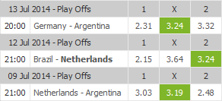
Betting odds are noted in a way that shows how much money will be returned for one unit of currency bet. For each game there are odds for the home team winning, odds for a tie, and odds for the away team winning. Higher odds then mean that more money is offered for every unit of currency bet on this option, and thus imply that the expected probability of this option being the outcome is lower.
Figure 1 – Example of how betting odds are presented to a bettor (Oddsportal.com, 2014)
Measures of probabilities are derived from betting odds, where $X_{iw}^{-1}$ are the odds of winning, $X_{id}^{-1}$ are the odds of a draw and $X_{il}^{-1}$are the odds of a loss, so this looks as follows:
$${πWin}_{i}= \frac{X_{iw}^{-1}}{X_{iw}^{-1}+X_{id}^{-1}+X_{il}^{-1}} {πDraw}_{i}= \frac{X_{id}^{-1}}{X_{iw}^{-1}+X_{id}^{-1}+X_{il}^{-1}} {πLoss}_{i}= \frac{X_{il}^{-1}}{X_{iw}^{-1}+X_{id}^{-1}+X_{il}^{-1}}$$
The odds are raised to the power of -1 because they then represent a fraction. After probabilities have been derived using these formulae they are regressed alongside the variables of interest to see how much of the effect is explainable by expectations. Arguably, if the result of a game was expected it provides no new information and should not lead to price changes. Unexpected losses meanwhile can be argued to provide new information, so if price changes only occur after these kind of results this is still in line with market efficiency. If pre-game expectations do not seem to matter for the impact, the effect can be said to be sentiment-driven. This opposes the idea of rationality in valuation.

3. Analysis
This research approaches its hypotheses by using the same techniques used by Edmans, García & Norli (2007), and Kaplansky & Levi (2010a). While their datasets included everything up to the 2006 World Cup, the dataset employed here also includes the 2010 and 2014 World Cup. This way it is possible to investigate the dynamics of the effect after publication (H₁ & H₂). Should the information about the effect be incorporated as would fit an efficient market, the effect will either be decreasing or have disappeared.
Besides using a larger dataset, there is also a comparison of subsamples within the dataset to examine the persistence over time. This approach was advanced by Schwert (2003), and Marquering, Nisser and Valla (2006). It serves the purpose of investigating the dynamic persistence of anomalies (Marquering, Nisser, & Valla, 2006). The subsamples considered here are for each World Cup separately.
H₃ is tested by measuring pre-game expectations of the results through betting odds. Arguably, if the result of a game was expected it provides no new information and should not lead to price changes. Unexpected losses meanwhile can be argued to provide new information. If price changes only occur after these kind of results this is still in line with market efficiency. If pre-game expectations do not seem to matter for the impact, the effect can be said to be sentiment-driven, which opposes the idea of rationality in valuation
The data used for these analyses is described in section 3.1. The structure of the analyses is discussed in section 3.2, and the analyses themselves are presented in section 3.3. After this the findings are summarized in section 3.3, before moving on to the concluding chapter of this thesis.

3.1 Data description
For these analyses the starting date of the datasets is equal to what is used in the original research by Edmans, Garcìa and Norli, which in turn is equal to what is offered by the Thomson Reuters Datastream. The biggest difference in datasets of course is that in this research the World Cups of 2010 and 2014 are also taken into account. Besides this however, the dataset for this research is also complemented by Bloomberg data. This allows the range of countries to be expanded, which could provide some insight into the robustness of the findings or increase the amount of observations and thus statistical power of the results.
For this research it is important to identify non-trading days. If these were to be included in the measurement of average trading days, they would distort average return downward because there is zero return on days on which there is no trade. Also, the dummies for holiday effects are determined by bank holidays, during which there is no trade. For both these reasons the dataset is limited to whenever volume data is available for countries. In practice this means that for the World Cup effect, most observations are from the 1990 World Cup onward, with a few remaining from 1986. For the exploitability analysis however, only U.S. data is required so observations are present from 1974 onward. See Appendix I for a summary of the dataset.
Match data has been collected from 1974 onward (downloaded from worldcup-history.com and double checked with Fifa.com’s publications). Also, to test whether expectations mediate the World Cup effect, betting odds data for the 2006, 2010 and 2014 World Cup has been collected from oddsportal.com, which provides average odds data per match from up to 48 sources.
3.2 Structure
Verifying the research done and applying this to a larger dataset is done in the same ways as the original researches. Firstly the original research by Edmans, Garcìa and Norli (2007) is replicated to test H₁. After that, the research done by Kaplanski & Levy (2010) is replicated to test H₂. In the following section their respective approaches are detailed.
For their analysis of the World Cup effect Edmans, García and Norli use a relatively uncomplicated model. Rit here is the continuously compounded daily local currency return on a broadly based stock market index for country i on day t. Rmt is the continuously compounded daily U.S. dollar return on Datastream’s world market index on day t. Besides this they also account for several anomalies that might be present. D_{t} represents dummy variables for Monday through Tuesday. Qt represents the first five days after a non-weekend holiday, identified as being a bank holiday, so with 0 turnover (Edmans, García, & Norli, 2007). This looks as follows:
R_{it} = γ_{0i} + γ_{1i} R_{it-1} + γ_{2i}R_{mt-1} + γ_{3i}R_{mt} + γ_{4i}R_{mt+1} + γ_{5i}D_{t} + γ_{6i}Q_{t} + ε_{it} (1)
Local market return is lagged and regressed with itself, making this an autoregressive model. This is useful because market performance could depend on past market performance, but it could also depend on variables determining past market performance. Models with the dependent variable lagged one period can be used to represent models where the impact of an independent variable is spread out over time while negating multicollinearity issues and improving degrees of freedom (Studenmund, 2011). World market return is included because stock markets might be integrated/correlated internationally. The lags and leads account for laggards and leaders on the global scale (Edmans, García, & Norli, 2007).
For their study of the World Cup effect, the researchers follow these steps:
- Normalize market return data by modelling the variance with a GARCH model. Volatility of stock returns varies over time. This heteroskedasticity influences the precision of standard errors and confidence intervals when OLS is used. This causes misrepresentations of significance (Engle, 2001). Here variance of stock market returns is modelled as an autoregressive function of variance in the previous period and the most recent squared residual. This squared residual captures new information in the period (Engle, 2001). The resulting variance series are then used to form a new time series with a mean equal to zero and a standard deviation equal to one. This time series is used as input for the model (1).

- Model local market return as in (1), as a function of lagged local market return, lagged world market return, world market return in the same period and world market return one period ahead. Also included in the function are several dummies relating to calendar anomalies to capture these effects. Model (1) is estimated separately for all countries.

- Analyze the residuals. As residuals are by definition the difference between observed and predicted return they reflect abnormal returns. This leaves to portion of return attributable to specific new information (Binder, 1998). They are regressed as a function of the variables of interest (one dummy for days after wins and one dummy for days after losses) to see how these affect the abnormal return. The coefficients for these give us the final results.
Kaplanski & Levy (2010a) follow roughly the same procedure, though their model looks slightly dissimilar to (1). As they measure an aggregate effect they cannot distinguish between losses and wins, as one’s win is automatically another’s loss. Because of this they only have one variable of interest, event effect days (EEDs) or event period effect days (EPEDs). EEDs are defined as game days after which the US market was still open. The EPEDs also include breaks and thus encompass the entire period from the first match to the day after the final match. The latter definition is included because it is more practical for an exploitable strategy. By investing once over a long period transaction costs are reduced (Kaplanski & Levy, 2010a).
Another thing different in Kaplanski and Levy’s approach is that they account for more calendar anomalies. Because of this they have more dummy variables in their equation. T_{t} stands for the first five days of the year. These are incorporated because during the turn of the year the selling-to-buying ratio on the stock market shifts. This happens partially for tax reasons, and possibly causes the January effect (Dyl & Maberly, 1992). P_{t} takes the annual period of the event (June and July) into the equation. This is to ensure results are not driven by a seasonal effect. J₁ and J₂ are dummy variables for the 10 days with the highest and lowest returns in the data range. This reduces sensitivity to outliers. Their model then looks as follows:
$R_{t}= γ_{0}+\sum_{i=1}^{2}{γ_{1i}R_{t-i}}+\sum_{i=1}^{4}{γ_{2i}D_{it}}+γ_{3}H_{t}+γ_{4}T_{t}+γ_{5}P_{t}+ γ_{6}E_{t}+\sum_{i=1}^{2}{γ_{7i}J_{it}}+ε_{t}$ (2)
Some things in this analysis are done different than in EGN’s analysis. They only take one day for the holiday effects, and incorporate one additional lag for return. They also standardize differently. Instead of giving the normalized return series a standard deviation of 1 and a mean of 1, they make sure the normalized series has the same characteristics as the original series. Another thing they do differently is that they do not run the regression of interest on residuals from a model specification. Instead they run the variable of interest alongside it in equation (5). These differences are taken into account in replicating their analysis.
Adding subjective probabilities to the model through betting odds will be done in the same way as the original analysis by EGN. This analysis offers the largest scope, with all the countries included. The probabilities derived from these odds will be included alongside the win- and loss effect coefficients. The next section will show how the analysis is done exactly and what outcomes are produced.
3.3 Results
Replicating EGN’s analysis is done in section 3.2.1. Here the effect of wins and losses is re-examined to see how these have held up over time. A Chow test determines whether or not there has been a structural break after publication of the effect. This tests market efficiency over time because the information could be expected to be incorporated/exploited as it became more known over time, diminishing the effect. It also puts the behavioral view to the test because in this view anomalies are structural, in which case they would not diminish.
A more dynamic analysis is also considered, in the form of per-Cup subsamples. Regressing these subsamples separately produces a time series of coefficients, confidence intervals and t-values, which is then analyzed for patterns (Marquering, Nisser, & Valla, 2006) This will also show whether the anomaly is dependable from period to period, which is important for investor considerations (Malkiel, 2003). Investor considerations are further considered when the exploitability of the World Cup effect is considered in section 3.2.2, in the way Kaplanski & Levy did their research. Section 3.2.3 is dedicated to the addition of pre-game expectations in the model, to see how and if the information available beforehand is incorporated. After that, section 3.3 presents a summary of the findings of these analyses.
3.3.1 World Cup effect
The model specifications for this part of the analysis were pulled straight from EGN’s 2007 paper, and are as follows:
R_{it} = γ_{0i} + γ_{1i} R_{it-1} + γ_{2i}R_{mt-1} + γ_{3i}R_{mt} + γ_{4i}R_{mt+1} + γ_{5i}D_{t} + γ_{6i}Q_{t} + ε_{it} (1)
By running this model for each country seperately a set of predicted conditional variances were obtained. These are then used to create a new normalised series. Here t variables a and b in this equation are chosen so that the series has a mean of 0 and a standard deviation of 1. This is specified by this equation; $R_{it}^{0}=a_{i}+b_{i} \left(\frac{1}{{\hat{σ}}_{it}}\right)R_{it}$ (3)
The variables a and b in this equation are chosen so that the series has a mean of 0 and a standard deviation of 1. In Stata this is approximated by dividing the R by the square root of the predicted variance. This should represent the (1/σ)*R_{it} part. This new series is then standardised by using the egen std(var) command for each country serparately. This subtracts means and divides by the standard deviation. This results in a mean of 0 and a standard deviation of 1 per country.
Model (1) is then regressed again, but now with the normalized returns, and with factor variables that interact everything in the model with everything else in the model. This produces refined residual estimates. On these residuals the regression of interest (5) is run, namely:
${\hat{ε}}_{it}= β_{0}+ β_{W}W_{it}+ β_{L}L_{it}+u_{it}$ (4)
Wit here is a dummy representing that a day was the first trading day after a win, and Lit so for a loss. The results from the regression (4) are shown in the top part of table 1. Running this specification for the dataset up to 2006 gives the results shown in table 1. Direct comparison with Edmans, García & Norli’s results is challenging due to the way their results are reported. However, when running the analyses with the same data and country range they used, a significant effect for losses, and an insignificant one for wins is found, which corresponds to what the original authors state (Edmans, García, & Norli, 2007). The results for World Cup losses found here for all games in the data up to 2006 do closely resemble those they report of the 32-country sample they compare with the ‘Top 7 countries’. Their estimate of the loss coefficient for all World Cup games in that case is -0.183, with a t-value of -2.60. Thus it is safe to conclude that the results of Edmans, Garcìa and Norli have been replicated.
The next step then is to include the 2010 and 2014 World Cups and see how that changes the estimates. Including the 2010 and 2014 World Cups increases the amount of observations for matches to 597 up from 401 (149 to 223 for losses), which is roughly an increase by half. If anything then, one should expect the statistical significance of the estimates to be higher when the dataset includes the 2010 and 2014 World Cup. However, it can be seen in the bottom part of table 1 that the overall loss effect seems to have decreased in significance. The measurement of the loss effect for group games does seem to have benefitted from the additional observations.

Table 1 - Results for replication of the analysis by EGN, and for the extended dataset |  | Wins |  |  | Losses
 |  | βwin | t-Values [p-Values] | N obs | βloss | t-Values [p-Values] | N obs
2006 | Group games | .2439764 | 1.93 [0.061] | 107 | .0355636 | 0.25 [0.801] | 92
2006 | Elimination games | .0591058 | 0.75 [0.456] | 64 | -.1273512 | -1.22 [0.229] | 57
2006 | All games | .0148938 | 0.22 [0.831] | 171 | -.1845332 | -2.49 [0.017] | 149
2014 | Group games | -.0432127 | -0.58 [0.566] | 168 | -.1595607 | -2.03 [0.048] | 140
2014 | Elimination games | .0667603 | 0.87 [0.391] | 91 | -.094784 | -1.21 [0.231] | 83
2014 | All games | -.0045415 | -0.08 [0.935] | 259 | -.1354171 | -2.34 [0.024] | 223
To see whether there has really been a change additional testing is required. The appropriate test for checking whether coefficients estimated over one group of data are equal to another is called the Chow test (Chow, 1960). To conduct a Chow test, first three regressions must be run. One for each sample, and one with both samples pooled. After this the Chow test statistic can be computed as:
$$\frac{({RSS}_{pooled}-({RSS}_{1}+{RSS}_{2}))/k}{({RSS}_{1}+{RSS}_{2})/(n_{1}+n_{2}-2k)}$$
Here RSS is the residual sum of squares, and k is the number of estimated parameters including the constant. The number of observations is represented by n. In this case the Chow test statistic equals ((166855.85-(129778.94+47371.79))/3)/((129778.94+47371.79)/(182732+80217-6)) = -5093.528314 which translates into a p-value below 0,0001. From this it seems that there has been a structural change in the effect after its publication.
To check the persistence of the World Cup effect it is useful to create subsamples in which to verify the effect. Also, with this method one can assess the reliability of the effect by checking whether the effect is present in all these subsamples. While the recommend approach is to use yearly subsamples (Marquering, Nisser, & Valla, 2006), that will not be possible in this case. Here the subsamples are constructed per World Cup. The data divided in World Cup subsamples is summarized in table 2. Though all cups have enough observations to run a regression it could be expected that results for later years show slightly higher significance due to increased observations.
Table 2 - Numbers of observations for World Cup subsamples | World cup (year)
Table 2 - Numbers of observations for World Cup subsamples | 1990 | 1994 | 1998 | 2002 | 2006 | 2010 | 2014
n Wins | 21 | 24 | 35 | 42 | 46 | 41 | 47
n Losses | 20 | 27 | 31 | 34 | 32 | 33 | 40
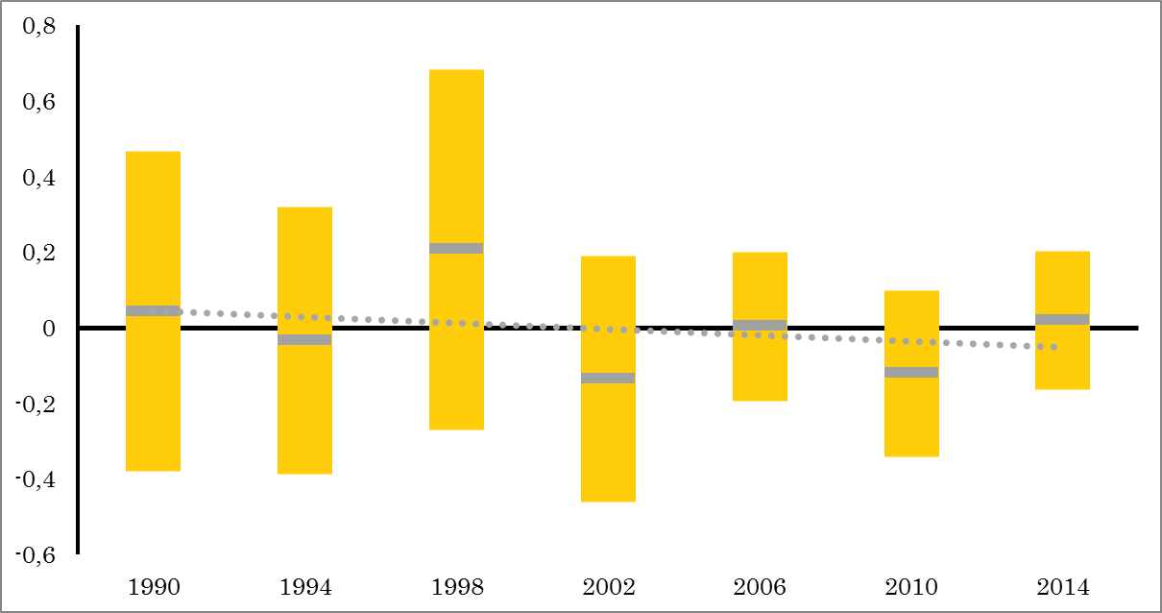
The actual results obtained for the World Cup subsamples show a very interesting picture however, as can be seen in the figures 2 and 3. Regarding wins the estimated results are rather unsurprising, there never seems to be a significant effect and both the coefficients and the significance seem to be randomly scattered around zero.
Figure 2 – Regression results for the win effect in individual World Cup subsamples. The yellow zones are confidence intervals, the dotted line is an OLS trend line of the coefficient.
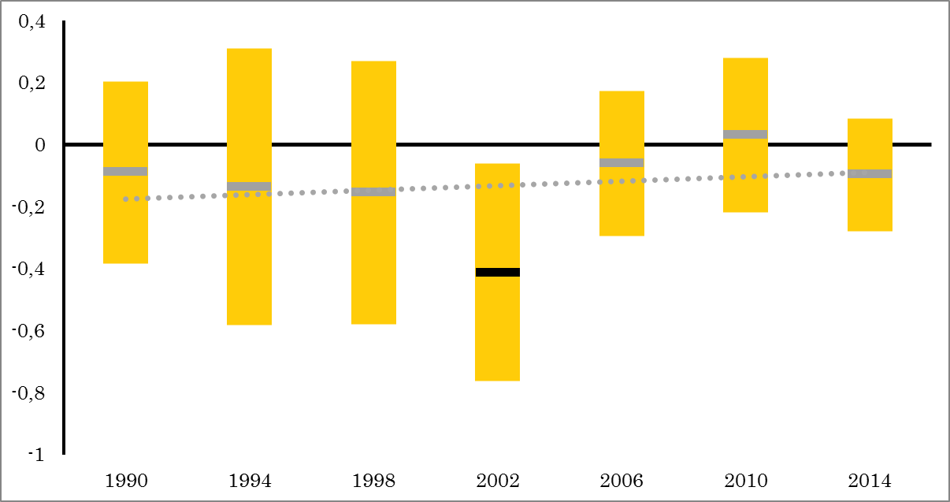
Regarding losses most of the estimated coefficients are negative, with the exception of 2010. Regarding significance the t-values show a general trend towards insignificance. There is however one alarming result here and that is the large outlier estimated from the 2002 World Cup data. At -.4113237 the coefficient is at least twice as large as anything estimated in the other regressions, while the significance level is the largest estimated.
This gives some indication then that the World Cup effect is a spurious result caused by a large outlier in 2002. To ascertain this it is necessary to see what happens when the effect is estimated without the 2002 results.
Figure 3 – Regression results for the loss effect in individual World Cup subsamples. Thee yellow zones are confidence intervals, the dotted line is an OLS trend line of the coefficient
Table 3 shows the results of the analysis when the 2002 World Cup is taken out of the dataset. The entire loss effect is immediately reduced in statistical significance, well beyond even the 10% level. Because of this it cannot be said that the World Cup effect has decreased or increased. Instead it appears the effect was spurious to begin with.

Table 3 – Results for replication of the analysis by Edmans, Garcìa and Norli minus the 2002 World Cup |  | Wins |  |  | Losses
 |  | βwin | t-Values [p-Values] | N obs | βloss | t-Values [p-Values] | N obs
2006 minus 2002 | Group games | .052914 | 0.45 [0.652] | 80 | -.2062518 | -1.62 [0.114] | 72
2006 minus 2002 | Elimination games | .082079 | 0.93 [0.361] | 49 | .0312788 | -0.40 [0.692] | 44
2006 minus 2002 | All games | .0641278 | 0.80 [0.430] | 129 | -.1145239 | -1.42 [0.166] | 116

The lack of statistical significance however does not automatically mean that the World Cup effect is not economically significant either. To ascertain the economic significance of the effect the exploitability of the effect is further investigated, using the approach by Kaplanski & Levi (2010).
3.3.2 Exploitability
To investigate the economic significance of the effect, firstly the aggregate effect is statistically examined. Calculating yearly subsamples is problematic as there are far less observations in this single-index scenario, so this is not done here. Secondly, Kaplanski & Levy’s investment strategy and actual market performance are analyzed. After that conclusions are drawn on the exploitability of the World Cup effect.
For the statistical analysis of the aggregate effect model specifications are taken from Kaplanski and Levy (2010a). Their model looks slightly dissimilar to (1), namely as follows:
$R_{t}= γ_{0}+\sum_{i=1}^{2}{γ_{1i}R_{t-i}}+\sum_{i=1}^{4}{γ_{2i}D_{it}}+γ_{3}H_{t}+γ_{4}T_{t}+γ_{5}P_{t}+ γ_{6}E_{t}+\sum_{i=1}^{2}{γ_{7i}J_{it}}+ε_{t}$ (5)
The series are normalized with a GARCH procedure and then given the same mean and standard deviation as the original series. The variable of interest is incorporated in equation (5), the results of the exploitability effect are thus derived directly from regressing this model specification. The results are detailed in table 4. The original authors find smaller coefficients (between -0.0022 and -0.0016) with higher significance (between -3.32 and 4.82). However, the signs are identical, so in both cases a significant negative effect is initially found.
When including the 2010 and 2014 World Cup, it is apparent the initially significant (p-value 0.033) effect for the event effect days is no longer significant on the 5%-level (p-value 0.061). To more formally test for a structural change a Chow test is again appropriate. The Chow test statistic in this case equals ((11388.3506-(10184.6258+2016.6361))/13)/((10184.6258+2016.6361)/(9338+1900-26)) = -57.46165732 which translates into a p-value of less than 0.0001 as well. Here it would thus also initially appear there has been a structural change in the effect since its publication.
However, following the surprising results in section 3.3.1, it is interesting to see what happens in this case when the 2002 World Cup is taken out of consideration. The results for this are also presented in table 4. Even though there is only a small percentage of observations removed, overall significance drops greatly. In this case too, the 2002 World Cup seems to have distorted the estimates.
Table 4 – Results for replication of the analysis by Kaplanski & Levi (2010), with and without the identified outlier 2002
Replication up to 2006 and 2014
 |  | γE | t-Values [p-Values] | n Obs
2006 | Event effect days | -.178816 | -2.13 [0.033] | 153
2006 | Event period effect days | -.1384005 | -1.80 [0.073] | 184
2014 | Event effect days | -.1444476 | -1.87 [0.061] | 190
2014 | Event period effect days | -.1169198 | -1.66 [0.097] | 227
Replication up to 2006 and 2014, excluding 2002 World Cup
 |  | γE | t-Values [p-Values] | n Obs
2006 | Event effect days | -.1521564 | -1.80 [0.072] | 134
2006 | Event period effect days | -.1100716 | -1.40 [0.161] | 162
2014 | Event effect days | -.1200529 | -1.54 [0.125] | 171
2014 | Event period effect days | -.092633 | -1.29 [0.197] | 205

The aggregate effect thus seems to be statistically non-significant as well, when controlling for outliers. This already gives some indication that we cannot reject H₂. However, this research also analyses market behavior and investment performance. To analyze this, comparing realized returns over the event period is useful. It should be noted here that here total return data is used, instead of the price data used by Kaplanski & Levy. This way of measuring also incorporates dividends and thus increases return on paper. Nevertheless the results are comparable. When comparing annualized return over the event effect days with the annual return for the same year, Annualized EED return is below annual stock return in the same year for all but two of the cases. The odds for this happening are small. Assuming both options are equally likely (p=0,5), the odds for only 2 cases out of 11 showing lower return are $\frac{11!}{2!\left(11-2\right)!}{0,5}^{2}{0,5p}^{11-2}$ = 2,7%.
This would imply some dependability for the effect. Further investigation is done by plotting the event effect period returns against the overall average stock returns and the average 3 month T-bill rate (See appendix 2). Only 3 out of the 11 World Cups in the dataset showed equal or higher returns than the average 3 month T-bill rate during the overall period. Only two of those showed higher returns than the average return on equity over the overall period.
Table 5 – Equity returns per World Cup compared to returns over the full year (Datastream, 2014) | Annual return | Annualised EED return | Annualised EED return trading days | EED return <full year?
1974 | -27,90% | -89,47% | -78,87% | Yes
1978 | 7,06% | 6,55% | 4,48% | Yes
1982 | 27,48% | 1,48% | 1,02% | Yes
1986 | 18,15% | -3,84% | -2,66% | Yes
1990 | -1,39% | -29,15% | -21,17% | Yes
1994 | 1,12% | -39,41% | -29,24% | Yes
1998 | 30,00% | 102,67% | 62,86% | No
2002 | -21,57% | -76,05% | -62,72% | Yes
2006 | 15,79% | -18,17% | -12,93% | Yes
2010 | 16,54% | -15,92% | -11,28% | Yes
2014 | 12,65% | 53,49% | 34,42% | No
From this table and graph it can be seen that the 1974 World Cup seems an even bigger outlier than the 2002 World Cup. When removing 1974 instead of 2002, the significance of the aggregate effect diminishes as well, see table 5. When removing both, according to Kaplanski & Levy’s own outlier analysis, the effect should still be significant on the 10% level. While the dataset in this research only runs from 1974 to 2014, theirs ran from 1950 to 2007. In this research, removing both lowers the p-value of the event effect period to 0.357. This makes clear the effect is not dependable, reducing any economic significance as well.
Table 6 – Outlier analysis aggregate World Cup effect |  | Data up to 2006 minus 1974, 2002
 |  | γE | t-Values [p-Values] | n Obs
2006 | Event effect days | -.178816 | -2.13 [0.033] | 153
2006 | Event period effect days | -.1384005 | -1.80 [0.073] | 184
2006 minus 1974 | Event effect days | -.1192746 | -1.40 [0.162] | 141
2006 minus 1974 | Event period effect days | -.070304 | -0.91 [0.365] | 167
2006 minus 2002 | Event effect days | -.1521564 | -1.80 [0.072] | 134
2006 minus 2002 | Event period effect days | -.1100716 | -1.40 [0.161] | 162
2006 minus 1974 and 2002 | Event effect days | -.0764818 | -0.92 [0.357] | 122
2006 minus 1974 and 2002 | Event period effect days | -.0250958 | -0.33 [0.742] | 145
Next, the investment strategy recommended by Kaplanski & Levy is assessed. As they found a significant negative return associated with World Cup events, the basic principle of this strategy is not participating in the stock market during these periods. Instead, one should opt for the safety offered by short-term Treasury bills. This simple strategy requires very few transactions, so these are disregarded for the analysis.
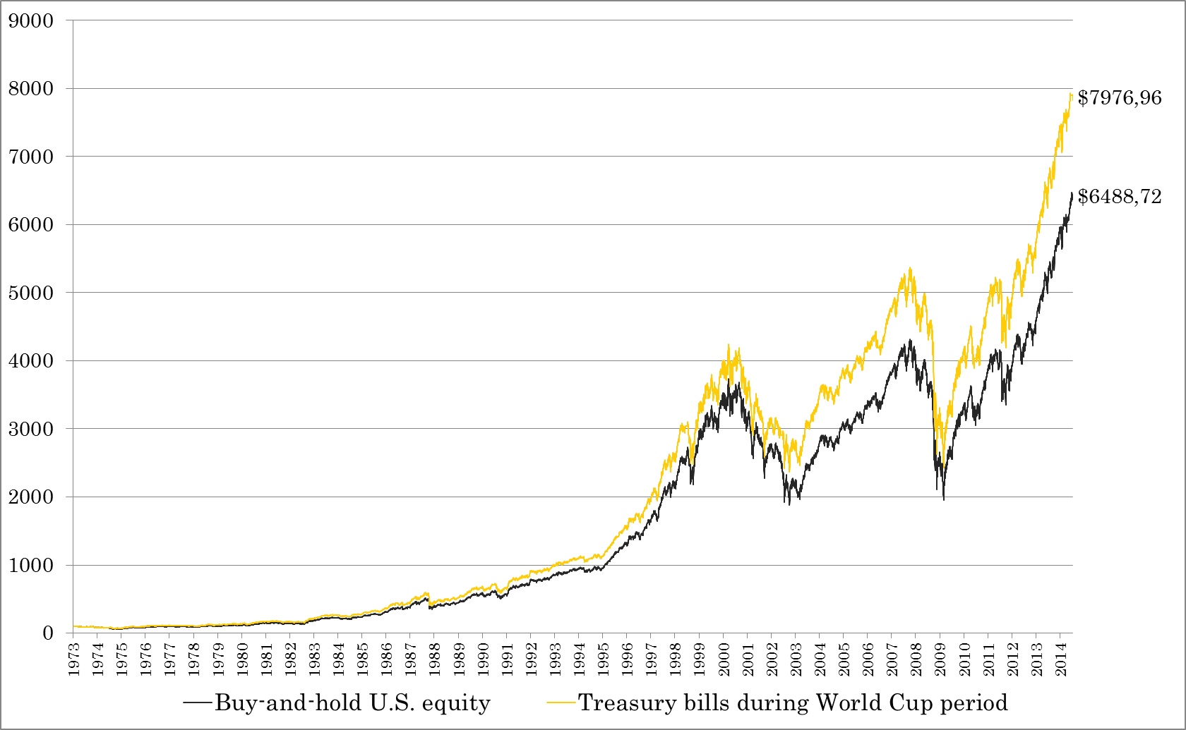
The black line in figure 4 shows the cumulative return for $100 invested in equity since 1973. The yellow line in figure 4 shows the cumulative return of investing $100 in the U.S. stock market, but switching to treasury bonds during World Cup periods. This is calculated over the entire period of the dataset in this research, so from 1973 to 2014. In cumulated value their strategy seems to beat the market. On 31-12-2014, $100 invested in equity at the start of 1973 would have been worth $6488,72, whereas with Kaplanski & Levy’s strategy the investment would have amounted to $7976,96. Their strategy would thus have outperformed the market by 22,94%. From this it would indeed appear the World Cup effect is exploitable. This would credit the effect with economic significance despite lacking statistical significance.
However, this research is in the position by answering the far more interesting question on whether someone would have made money actually following this strategy after publication of the effect. This tests the economic significance of the effect. Given a certain information set θ, there is economic significance if a profitable trading strategy can be conceived on the basis of θ.
Figure 4 – Graph showing the cumulated value of $100 invested in equity versus $100 invested in equity, but switched to 3 month T-bills during the World Cup period. This covers the entire dataset of this research, so from 1974 to 2014 (Datastream, 2015)(U.S. Treasury, 2015)
Kaplanski & Levy’s research was published in April 2010, so the first day of May 2010 will be chosen as the starting point for this part of the analysis. It should be noted that because of this starting point this part of the analysis contains none of the identified outliers. Again, as in the previous part, the results for investing in US equity versus switching to T-bills are plotted.
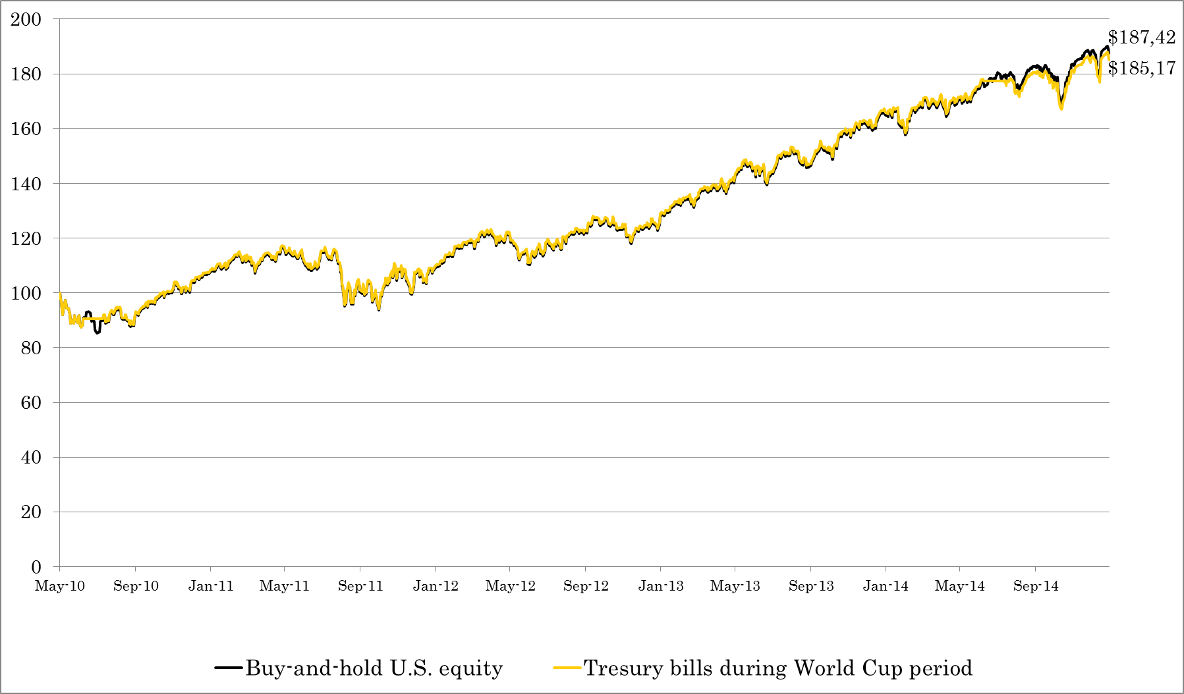
The results, seen in figure 5, are admittedly close, with the market beating the strategy by 1,22%. The verdict is clear however, the strategy has thusfar been unable to beat the market. Given that the presence of the effect is disputable, and that in practice the investment strategy does not beat the market, this research cannot reject H₂ (The World Cup effect is not exploitable now).
3.3.3 Role of expectations
The World Cup effect appears to be statistically and economically insignificant upon further analysis. Nevertheless it is interesting to see if pre-game expectations offer explanatory power.
Figure 5 – Graph showing the cumulated value of $100 invested in equity versus $100 invested in equity, but switched to 3 month T-bills during the World Cup period. The starting point here is May 2010, just after the publication of the investment strategy. (Datastream, 2015)(U.S. treasury, 2015)
In this section a measure of expectations about game outcomes is introduced, which is derived from betting odds on the game (see section 2.2). Introducing this into the analysis could capture the effect of expected wins/losses. Arguably, if the result of a game was expected it provides no new information and should not lead to price changes. Should the subjective probabilities be statistically significant with a negative coefficient that would mean unexpected results lead to higher abnormal return.
Checking the role of expectations can only be done with recent data, as data for betting odds was only available ranging from the 2006 World Cup to the 2014 World Cup. For this interval of the dataset the estimates for the World Cup Effects are shown in table 6. This data also does not contain any of the outlier years.
Table 7 - Comparison of World Cup effect estimates with and without expected probabilities. | Excluding subjective probabilities | Including subjective probabilities
All games
Wins
n Obs | 129 | 217
βwin | .0277872 | .0439783
t-Values [p-Values] | 0.59 [0.558] | -0.40 [0.691]
Losses
n Obs | 116 | 189
βloss | -.0431483 | -.0368093
t-Values [p-Values] | -0.69 [0.497] | -0.32 [0.749]
Odds
βπWin | - | .3133502
t-Values [p-Values] | - | 0.39 [0.697]
βπLoss | - | .225182
t-Values [p-Values] | - | 0.29 [0.771]
As can been seen in table 6, for the 2006, 2010 and 2014 World Cups there is no significant loss effect, nor any other effect. When the pre-game expectations for winning and losing are included in the regression, nor on their own, nor in any combination of cross terms are these subjective probabilities significant. There is thus nothing that seems to indicate that for unexpected wins/losses the effect is stronger. Thus we can reject H₃: The World Cup effect is stronger when results are unexpected.
3.4 Findings
The results found when replicating the research done by Edmans, Garcìa and Norli (2007) and Kaplanski & Levy (2010) initially seemed to support the view that anomalies disappear over time. Doing the same analyses as these researchers, then adding new data showed a decrease in size and significance of the effects found. Using EGN’s methodology, the original effect found for overall losses showed a coefficient of -,1845332 and a p-value of 0,017. When including the 2010 and 2014 World Cup, the effect found showed a coefficient of -,1354171 and a p-value of 0,024. Using Kaplanski & Levy’s methodology, the effect found for the World Cup game days in general showed a coefficient of -,178816 and a p-value of 0,033. When including the 2010 and 2014 World Cup, the effect found showed a coefficient of -,1444476 and a p-value of 0,061. These decreases occur despite the fact that there is an increase in observations of respectively 59,3% and 24,2%.
Chow tests performed in both cases determined that the estimated coefficients were unequal between the old and new dataset. This would indicate that the effect indeed had diminished since its publication. Such diminishing would be in line with behavior expected under the Efficient Market Hypothesis.
However, further investigation in both these cases revealed that the effect is highly influenced by outliers. Using EGN’s methodology, removing the 2002 World Cup from the dataset the estimates of the loss effect showed a coefficient of -.1145239 with a p-value of 0,166. Using Kaplanski & Levy’s methodology, removing the 1974 and the 2002 World Cup from the dataset the estimates of the loss effect showed a coefficient of -.0764818 with a p-value of 0.357 for the event effect days, and a coefficient of -.0250958 with a p-value of 0.742 for the entire period. The diminishing of the estimates is thus explainable by the reduced influence of the outliers when increasing observations.
Finally, introducing a measure of subjective probabilities could have helped identify an effect for wins/losses that were unexpected. However, this offered no additional explanatory power.
4. Conclusions
The results tell an unexpected, but nevertheless interesting story regarding this specific anomaly, but also regarding anomalies and market efficiency in general. In the next section the results will be discussed, after which suggestions for future research will be given.
4.1 Discussion
This thesis took multiple approaches to verify and further investigate a specific anomaly. When investigating this anomaly, I was able to replicate everything. Initially it appeared that the effects were diminishing over time, as would fit the Efficient Market Hypothesis. However, further investigation revealed that the decrease was due to reduced influence of a few outliers (1974 & 2002). Without these outliers, the effect was statistically insignificant.
Kaplanski & Levy (2010a) had also noticed these outlier years and looked for important events during the World Cup periods, like the beginnings and ends of wars, but found nothing. A visual inspection shows no big highs or lows, instead there is a continuous global downwards movement in these periods (see figure 6).
Additional investigation into significant events during the outlier World Cups was done for this thesis by aggregating global news of the period from various historical sources (The New York Times, 2015)(Historyorb.com, 2015). The 3 biggest decreases during the 1974 World Cup occurred on June 14, June 21 and June 26. The 3 biggest decreases during the 2002 World Cup occurred on June 14, June 24 and June 26.
The only economic event during the 1974 World Cup was on the first day. On June 13 1974, the IMF set up an ‘oil facility’, a special fund for loans to nations whose balance of payments had been affected by the high oil prices caused by the oil crisis at that time. This, if anything, should have turned the tide for the financial markets of the day. During the 2002 World Cup there were no apparent historical events of economic significance.
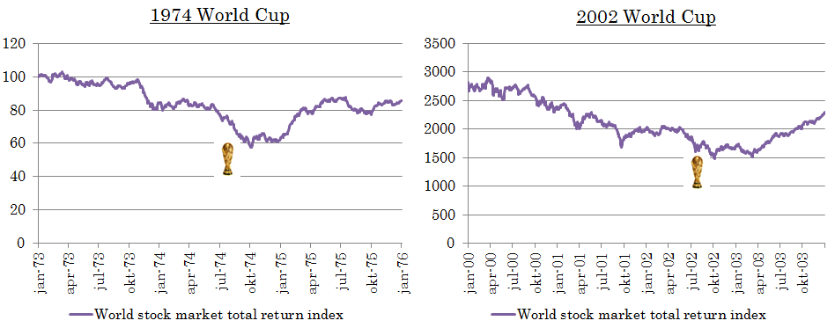
All this concerns static events however, at a given point in time. Looking beyond that there is definitely an explanation for these outliers. This explanation lies in dynamic economic developments. In both 1974 and 2002 there was a global stock market downturn associated with economic recessions. As mentioned, during the 1974 World Cup the global economy was still dealing with the aftermath from the 1973 oil crisis. The 2002 World Cup occurred during the recovery period after the collapse of the global dotcom-bubble of the late 90’s.
Figure 6 – Graph showing global stock market developments during the 1974 and 2002 World Cup periods (Datastream, 2015)
The World Cup events did not change these movements, but because of these movements there were significant negative returns during the event window. This brings an important issue to light regarding anomalies, namely that there are more important forces that dictate the stock market’s performance. Anomalies found thus run the risk of being confounded with these.
As an example of an important economic force, take for instance the United States Gross Domestic Product. Comparing quarterly US GDP growth and average/median US GDP growth over time with the World Cup periods shows that a majority of these happen during periods with below-average US GDP growth.
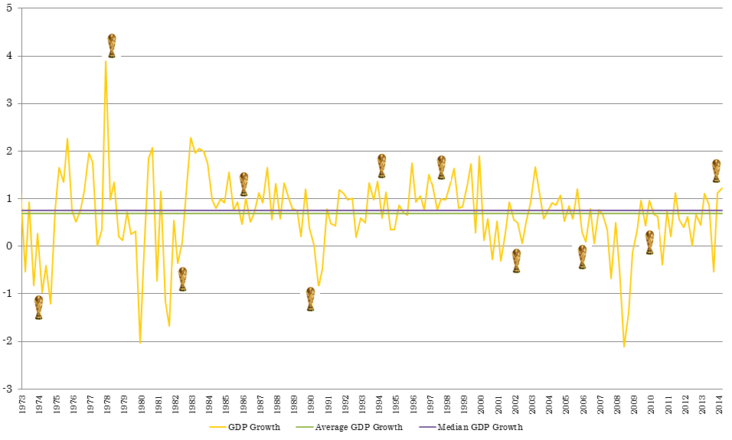
It is far more likely that changes in GDP growth affect stock markets, than that a soccer match would. The World Cup events themselves meanwhile are not likely to influence GDP as their effect is found to be short-term at best, if it exists at all. However, not accounting for general economic developments, one could draw confounded conclusions regarding the influence of an event, as was done in this case.
Figure 7 – Graph showing quarterly US GDP growth, average/median US GDP growth and the World Cup periods (Datastream, 2015)
Looking beyond statistical issues, it is clear the World Cup effect holds no economic significance either. Its dependency on outliers offers no reliability for investment purposes. Investors who had chosen to follow the strategy outlined by Kaplanski & Levy (2010) would have underperformed the market by 1,22%.
As is clear from the literature on market efficiency, there are many anomalies that pose a challenge to the Efficient Market Hypothesis. These might very well lead one to reject the statement that the EMH ‘seems a good approximation to reality’ (Fama, 1970). The World Cup effect is not one of them however.
4.2 Suggestions for future research
This research was unable to find a significant influence of subjective probabilities. This could be because the probabilities were static, they were merely the closing odds before the start of the game. Incorporating probabilities dynamically, allowing them to evolve in the time leading up to the event, has benefitted in event studies using prediction markets. Using these probabilities as objective probabilities, more realistic event windows can be chosen and noise in correlations can be reduced (Snowberg, Wolfers, & Zitzewitz, 2011). Further research using betting odds could incorporate how these evolve over time.
Another limitation of this research is that only the next-day effect for World Cup events was investigated. However, shareholders whose favorite team has recently won have been seen to be more optimistic about their portfolio’s expected return and volatility for a few days after. This could lead to overinvestment, which would affect markets for longer periods (Kaplanski, Levy, Veld, & Veld-Merkoulova, Forthcoming). What happens to markets over time could also be an important factor to be considered when investigating this effect.
When investigating the influence of the World Cup events with historical data it is important to consider that in early years the results were not disseminated directly after the game due to technological limitations. A correct starting point would be the 1966 World Cup, which was the first one to be broadcasted live worldwide, with viewership in the hundreds of millions (Chisari, 2006).
Eugene Fama might not be wrong in his critique that besides a notion of market inefficiency, no specific alternative to market efficiency is ever tested (Fama, 1998). During my literature review I came across very little alternative models, none of them widely tested. We are now still, as Michael C. Jensen put it, at a stage where widely scattered and as yet incohesive evidence is arising which seems to be inconsistent with the theory (Jensen, 1978). If behavioral finance is to complete the Kuhnian paradigm shift, perhaps further research should move into developing alternatives for the EMH.
However, the most important recommendation to be made in light of this research is to waterproof anomalies. In this case, much like in the research by Marquering, Nisser and Valla (2006), apparent anomalies fell apart upon further investigation. In the way of statistics, verifying the anomalies found using subsampling can help make a more accurate conclusion regarding its existence. Economically speaking it is also important to account for general economic developments when assessing the impact of an event. If no care is taken to solidify these results they are indeed, as Fama (1991) argues, merely stylized facts to be explained by other asset pricing models.
These other asset pricing models would ideally incorporate more important economic forces. As always any results obtained these models will be vulnerable to the joint hypothesis problem. But when using daily data this is less of a problem. This still leaves a bit of uncertainty regarding results obtained, but Fama (1970) put it best when he said that it is the unavoidable price one must give to add empirical content to EMH research. Especially if it produces more valid results, that fact that no model is a complete description of the systematic patterns in returns (Fama, 1998), does not mean that we should not try.

Bibliography

References
Al-Hajieh, H., Redhead, K., & Rodgers, K. (2011). Investor sentiment and calendar anomaly effects: A case study of the impact of Ramadan on Islamic Middle Eastern markets. Research in International Business and Finance, 345– 356.
Ashton, J. K., Gerrard, B., & Hudson, R. (2003). Economic impact of national sporting success: evidence from the London stock exchange. Appleid Economic Letters, 783-785.
Binder, J. (1998). The Event Study Methodology Since 1969. Review of Quantitative Finance and Accounting, 111–137.
Busse, J. A., & Green, T. C. (2001). Market Efficiency in Real-Time. Journal of Financial Economics, 415-437.
Campbell, J. Y., & Shiller, R. J. (1988). Stock Prices, Earnings and Expected Dividends. The Journal of Finance, 661-675.
Castellani, M., Pattitoni, P., & Patuelli, R. (2013). Abnormal Returns of Soccer Teams: Reassessing the Informational Value of Betting Odds. Journal of Sports Economics, 1-25.
Chisari, F. (2006). When football went global : televising the 1966 World Cup. Historical Social Research, 42-54.
Chow, G. C. (1960). Tests of equality between sets of coefficients in two regressions. Econometrica, 591-604.
crsp.com. (2014, 08 13). History. Opgeroepen op 08 13, 2014, van Center for Research in Security Prices: http://www.crsp.com/about-crsp/history
De Bondt, W., Muradoglu, G., Shefrin, H., & Staikouras, S. K. (2008). Behavioral Finance - Quo Vadis? Journal of Applied Finance, 1-15.
Dyl, E. A., & Maberly, E. D. (1992). Odd-lot transactions around the turn of the year and the January effect. Journal of Financial and Quantitative Analysis, 591-602.
Edmans, A., García, D., & Norli, Ø. (2007). Sports Sentiment and Stock Returns. The Journal of Finance, Volume 62, Issue 4, pages 1967–1998.
Ehrmann, M., & Jansen, D.-J. (2012). The pitch rather than the pit: investor inattention during FIFA World Cup matches. De Nederlandche Bank Working Paper, no. 337.
Ehrmann, M., & Jansen, D.-J. (2014). It hurts (stock prices) when your team is about to lose a soccer. De Nederlandsche Bank Working Paper, No. 412.
Engle, R. (2001). GARCH 101: The Use of ARCH/GARCH Models in Applied Econometrics. Journal of Economic Perspectives, 157–168.
Fama. (1970). Efficient Capital Markets - a Review of Theory and Empirical Work. The Journal of Financa, 383-417.
Fama. (1991). Efficient Capital Markets: II. The Journal of Finance, Vol. 46 1575-1617.
Fama. (1998). Market efficiency, long-term returns, and behavioral finance. Journal of financial economics, 283-306.
Fama, E., Fisher, L., Jensen, M., & Roll, R. (1969). The Adjustment of Stock Prices to New Information. International Economic Review, 1-21.
Finucane, M. L., Alhakami, A., Slovic, P., & Johnson, S. M. (2000). The Affect Heuristic in Judgments of Risks and Benefits. Journal of Behavioral Decision Making, 1-17.
Friedrich von Hayek. (1945). The use of knowledge in society. The American Economic Review, 519-530.
Gabriel, P. E., & Marsden, J. R. (1990). An Examination of Market Efficiency in British Racetrack Betting. Journal of Political Economy, pp. 874-885.
Grossman, S. J., & Stiglitz, J. E. (1980). On the impossibility of informationally efficient markets. The American Economic Review, 393-407.
Hanson, R., Oprea, R., & Porter, D. (2006). Information aggregation and manipulation in an experimental market. Journal of Economic Behavior and Organisation, 449-459.
Hirt, E. R., Zillmann, D., Erickson, G. A., & Kennedy, C. (1992). Costs and Benefits of Allegiance: Changes in Fans' Self-Ascribed Competencies After Team Victory Versus Defeat. Journal of Personality and Social Psychology, Vol. 63, No. 5, 724-738.
Hsee, C. K., & Kunreuther, H. C. (2000). The affection effect in insurance decisions. Journal of Risk and Uncertainty, 141-159.
Jensen, M. C. (1978). Some Anomalous Evidence Regarding Market Efficiency. Journal of Financial Economics, 95-101.
Kahneman, D., & Tversky, A. (1979). Prospect theory: An analysis of decision under risk. Econometrica, 263-291.
Kahneman, D., Knetsch, J. L., & Thaler, R. H. (1991). Anomalies: The Endowment Effect, Loss Aversion, and Status Quo Bias. The Journal of Economic Perspectives, 5(1), pp. 193-206.
Kamstra, M. J., Kramer, L. A., & Levi, M. D. (2000). Losing Sleep at the Market: the Daylight Saving Anomaly. The American Economic Review, 1005-1010.
Kamstra, M. J., Kramer, L. A., & Levi, M. D. (2003). Winter Blues: a SAD Stock Market Cycle. The American Economic Review, vol. 93, issue 1, pages 324-343.
Kaplanski, G., & Levy, H. (2010a). Exploitable Predictable Irrationality: The FIFA World Cup Effect on the U.S. Stock Market. Journal of Financial and Quantitative Analysis, Vol. 45, No. 2, pp. 535–553.
Kaplanski, G., & Levy, H. (2010b). Sentiment and stock prices: The case of aviation disasters. Journal of Financial Economics, 174–201.
Kaplanski, G., Levy, H., Veld, C., & Veld-Merkoulova, Y. (Forthcoming). Do Happy People Make Optimistic Investors? Journal of Financial and Quantitative Analysis.
Kliger, D., & Levy, O. (2008). Mood impacts on probability weighting functions: “Large-gamble” evidence. The Journal of Socio-Economics, 1397–1411.
Lamont, O. A., & Thaler, R. H. (2003). Can the Stock Market Add and Subtract? Mispricing in Tech Stock Carve-outs. Journal of Political Economy, Vol. 111 No. 227-268.
Levitt, S. D. (2004). Why are gambling markets organised so differently from financial markets? The Economic Journal, 223-246.
Maberly, E. D., & Pierce, R. M. (2004). Stock market efficiency withstands another challenge: Solving the “sell in May/buy after Halloween” puzzle. Econ Journal Watch, 29-46.
Malkiel, B. G. (1989). Is the Stock Market Efficient? Science, 1313-1318.
Malkiel, B. G. (2003). The Efficient Market Hypothesis and its critics. The Journal of Economic Perspectives, 59-82.
Marquering, W., Nisser, J., & Valla, T. (2006). Disappearing anomalies: a dynamic analysis of the persistence of anomalies. Applied financial economics, 291-302.
Oddsportal.com. (2014, 08 13). World Cup 2014 Results & Betting Odds. Opgehaald van Oddsportal: www.oddsportal.com
Palomino, F., Renneboog, L., & Zhang, C. (2005). Stock price reaction to short-lived public information: the case of betting odds. Tilburg Law and Economics Center working paper .
Palomino, F., Renneboog, L., & Zhang, C. (2009). Information salience, investor sentiment, and stock returns: The case of. Journal of Corporate Finance, 368–387.
Sauer, R. D. (1998). The Economics of Wagering Markets. Journal of Economic Literature, pp. 2021–2064.
Saunders, E. M. (1993). Stock Prices and Wall Street Weather. The American Economic Review, pp. 1337-1345.
Schiller, R. J. (1987). The Volatility of Stock Market Prices . Science, Vol. 235 no. 4784 pp. 33-37.
Schwert, G. (2003). Anomalies and Market Efficiency. In M. H. G.M. Constantinides, Handbook of the Economics of Finance (pp. 937-972). Amsterdam: Elsevier Science.
Shafir, E., & LeBoeuf, R. A. (2002). Rationality. Annual Review of Psychology, Vol 53 491–517.
Shin, H. S. (1992). Prices of state-contingent claims with insider traders, and the favorite-longshot bias. The Economic Journal, pp. 426-435.
Snowberg, E., & Wolfers, J. (2010). Explaining the favorite-longshot bias: Is it risk-love or misperceptions? National Bureau of Economic Research working paper no. 15923.
Snowberg, E., Wolfers, J., & Zitzewitz, E. (2011). How prediction markets can save event studies. NBER Working paper no. 16949.
Snowberg, E., Wolfers, J., & Zitzewitz, E. (2011). How prediction markets can save event studies. NBER Working Paper 16949 , 1-26.
Studenmund, A. (2011). Using Econometrics - A Practical Guide, 6th Edition. Boston: Pearson Education.
Thaler, R. H., & Ziemba, W. T. (1988). Anomalies - Parimutuel betting markets; Racetracks and Lotteries. Journal of Economic Perspectives, 161-174.
Tversky, A., & Kahneman, D. (1974). Judgment under uncertainty: Heuristics and Biases. Science, 1124-1131.
Verheyden, T., de Moor, L., & Van den Bossche, F. (2014). A tale of market efficiency. Review of Economic and Business Literature, 139-156.
Witte, D. R., Bots, M. L., Hoes, A. W., & Grobbee, D. E. (2000). Cardiovascular mortality in Dutch men during 1996 European football championship: longitudinal population study. BMJ, Volume 231 23-30.
Wolfers, J., & Zitzewitz, E. (2006). Prediction Markets in Theory and Practice. National Bureau of Economic Research working paper no. 12083, 1-11.

Other sources
Belgrade stock exchange (2014), BELEX15 stock data, retrieved from: http://www.belex.rs/eng/trgovanje/indeksi/belex15/istorijski/3y
Bloomberg (2014), various indices retrieved from the Bloomberg Terminal
Historyorb.com (2015), historical event data, retrieved from: http://www.historyorb.com/today/events.php
New York Times – On This Day (2015), historical event data, retrieved from:
http://learning.blogs.nytimes.com/on-this-day/
Oddsportal.com (2014), betting odds data, retrieved from: http://www.oddsportal.com/soccer/world/world-cup/results/
Thomson Reuters Datastream (2015), various indices retrieved from Datastream
United States Treasury (2014), Historical T-bill rate data, retrieved from: http://www.treasury.gov/resource-center/data-chart-center/interest-rates/Pages/default.aspx
Appendix
Appendix I – Data per country
Presented here is an overview of the countries that are included in the dataset for this research, as well as the starting date of their data, and the amount of observations for wins, draws and losses that are present in the dataset.
Country | Start | Win | Draw | Lose | Country | Start |  | Win |  | Draw |  | Lose
Argentina | 8/1993 | 19 | 2 | 7 | New Zealand | 1/1990 |  | 0 |  | 3 |  | 0
Australia | 1/1984 | 2 | 2 | 6 | Nigeria | 9/2009 |  | 1 |  | 2 |  | 4
Austria | 8/1986 | 1 | 2 | 3 | Norway | 1/1983 |  | 1 |  | 4 |  | 2
Belgium | 1/1986 | 12 | 6 | 9 | Poland | 1/1995 |  | 1 |  | 0 |  | 5
Bosnia | 5/2008 | 1 | 0 | 2 | Portugal | 1/1992 |  | 8 |  | 3 |  | 6
Brazil | 1/1995 | 23 | 2 | 6 | Romania | 5/1997 |  | 2 |  | 1 |  | 1
Canada | 1/1974 | 0 | 0 | 3 | Russia | 1/1998 |  | 1 |  | 2 |  | 3
Chile | 7/1989 | 4 | 3 | 4 | Saudi Arabia | 5/2006 |  | 0 |  | 1 |  | 2
China | 5/1994 | 0 | 0 | 3 | Scotland | 10/1983 |  | 1 |  | 1 |  | 4
Colombia | 3/1992 | 6 | 0 | 5 | Serbia | 10/2005 |  | 1 |  | 0 |  | 5
Croatia | 10/2005 | 1 | 2 | 3 | Slovakia | 11/2009 |  | 1 |  | 1 |  | 2
Czech Republic | 1/1995 | 1 | 0 | 2 | Slovenia | 1/1999 |  | 1 |  | 1 |  | 4
Denmark | 10/1991 | 5 | 2 | 5 | South Korea | 9/1987 |  | 6 |  | 6 |  | 14
England | 10/1986 | 11 | 8 | 9 | South Africa | 1/1990 |  | 2 |  | 4 |  | 3
France | 6/1988 | 14 | 5 | 6 | Spain | 2/1990 |  | 19 |  | 4 |  | 8
Germany | 6/1988 | 34 | 5 | 6 | Sweden | 1/1982 |  | 6 |  | 6 |  | 6
Ghana | 1/2011 | 1 | 1 | 1 | Switzerland | 1/1990 |  | 6 |  | 3 |  | 6
Greece | 1/1990 | 2 | 1 | 7 | Turkey | 1/1988 |  | 4 |  | 1 |  | 2
Ireland | 11/2000 | 1 | 2 | 1 | Ukraine | 2/2005 |  | 2 |  | 0 |  | 2
Italy | 7/1986 | 21 | 6 | 9 | United States | 1/1973 |  | 4 |  | 6 |  | 16
Japan | 12/1990 | 4 | 3 | 10
Mexico | 5/1989 | 8 | 7 | 9
Morocco | 4/1994 | 1 | 1 | 4
Netherlands | 2/1986 | 20 | 6 | 8 | Total observations |  | 259 |  | 115 |  | 223

Appendix II – U.S. equity returns per World Cup
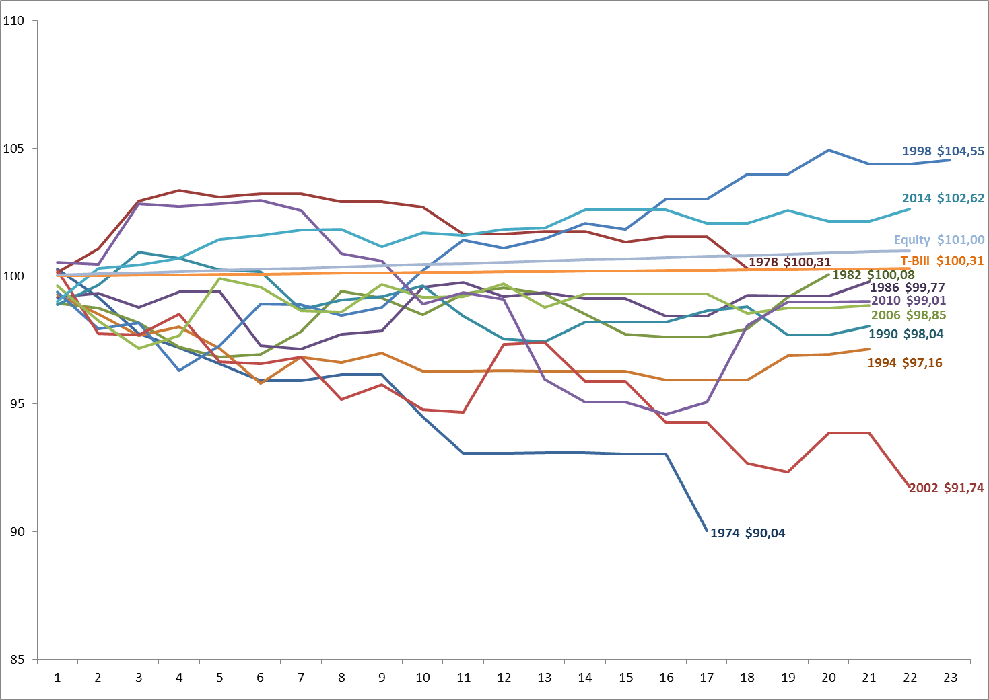
Figure 8 – Graph showing the average return over the Event Effect Days per World Cup, against the average equity and 3 month T-bill return rate

